ALVA'S INSTITUTE OF ENGINEERING & TECHNOLOGY
TECHNICAL PROJECT DOCUMENTATION
AI-Powered Predictive Analytics and Early Warning System for Infrastructure Project Monitoring

PROJECT DETAILS
Project id | SIH26103
Domain | Monitoring of real-world infrastructure projects

MEMBERS
Name | USN
Nandaksha V N | 4AL23CS091
Vishwanath | 4AL23CS186

TABLE OF CONTENTS
Abstract 4
1. Introduction 5
1.1 Background 5
1.2 Problem Statement 5
1.3 Proposed Solution: InfraWatch AI 5
1.4 Objectives 6
1.5 Scope and Boundaries 6
1.6 Significance 7
1.7 Organisation of the Report 7
1.8 Document Conventions and Status Labels 7
2. Background and Related Concepts 9
2.1 Cost and Schedule Overruns in Infrastructure 9
2.2 Conventional Monitoring Indicators 9
2.3 Machine Learning for Risk Prediction 9
2.4 Explainable AI and SHAP 9
2.5 Large Language Models and Grounding 9
2.6 Gap Addressed by This Work 10
3. Requirements Analysis 11
3.1 Stakeholders and User Roles 11
3.2 Functional Requirements 11
3.3 Non-Functional Requirements 12
3.4 Representative Use Cases 12
4. System Architecture and Design 13
4.1 Architectural Overview 13
4.2 Technology Stack and Rationale 13
4.3 Backend Package Structure 14
4.4 ML Service Structure 14
4.5 Frontend Structure 14
4.6 Key Interaction: Refreshing a Project Assessment 14
4.7 Configuration and Secrets 14
5. Database Design 15
5.1 Design Principles 15
5.2 Tables and Their Purpose 15
5.3 Core Table Definitions 16
5.4 Monthly Monitoring Data 16
5.5 Indexing and Integrity 16
5.6 Seed Data 17
6. Data and Feature Engineering 18
6.1 Data Sources 18
6.2 Prediction Targets 18
6.3 Experiment A: CUF-Only Features 18
6.4 Experiment B: CUF Plus Engineered Features 18
6.5 Data Quality Handling 19
6.6 Preventing Data Leakage 19
7. Machine Learning Methodology 20
7.1 Overall Pipeline 20
7.2 Models Compared 20
7.3 Validation Protocol 20
7.4 Evaluation Metrics 21
7.5 Model Selection 21
7.6 Explainability with SHAP 21
7.7 Model Serving and Versioning 21
8. Risk Scoring, Early Warning and Recommendations 23
8.1 Overall Risk Score 23
8.2 Early-Warning Rules 23
8.3 Severity Levels 24
8.4 Duplicate Prevention 24
8.5 Recommendation Engine 24
9. Backend, Security and API Design 26
9.1 API Conventions 26
9.2 Endpoint Catalogue 26
9.3 Authentication and Authorisation 26
9.4 ML Client Layer 26
9.5 Error Handling 27
9.6 Data Upload Validation 27
10. Frontend and User Experience 28
10.1 Design Approach 28
10.2 Pages 28
10.3 Dashboard Content 28
10.4 Robustness 28
11. AI Project Intelligence Assistant 29
11.1 Role Separation 29
11.2 Grounding Architecture 29
11.3 FACT, PREDICTION and RECOMMENDATION 29
11.4 Hallucination and Data-Validation Safeguards 29
11.5 Supported Questions 30
12. Testing, Deployment and Development Plan 31
12.1 Test Strategy 31
12.2 Containerisation 31
12.3 Phased Development Plan 31
12.4 Demonstration Flow 32
12.5 Deployment Notes 32
13. Evaluation Framework and Expected Outputs 33
13.1 Classification Comparison (Cost-Overrun Target) 33
13.2 Regression Comparison (Overrun Percentage / Delay Months) 33
13.3 How Results Will Be Interpreted 33
13.4 Quality Checklist Before Demonstration 33
14. Limitations, Ethics, Future Work and Conclusion 35
14.1 Limitations 35
14.2 Ethical and Governance Considerations 35
14.3 Future Enhancements 35
14.4 Conclusion 35
References 37
Appendix A: Glossary 39
Appendix B: Configuration Reference 40

Abstract
Large infrastructure projects, such as those in transport, energy, water and sanitation, communication, mining, steel, coal and social infrastructure, are prone to cost and schedule overruns, yet routine monitoring is largely descriptive. This report presents InfraWatch AI, an AI-powered decision-support system that monitors real-world infrastructure projects (not software projects) and provides predictive, explainable early warnings. The platform stores project master data and monthly monitoring observations, computes engineered indicators such as progress gap, cost growth, expenditure/progress ratio and milestone delay rate, and uses machine-learning models to estimate cost-overrun risk and time (schedule) overrun risk, from which an overall 0–100 project risk score is derived.
A controlled experiment is designed to compare Currently Used Fields (CUF-only, Experiment A) with CUF plus engineered features (Experiment B), and a logistic-regression baseline with decision tree, random forest and XGBoost models, using chronological validation to avoid data leakage. Only actual evaluation metrics are to be reported; results are to be updated after final model evaluation. SHAP identifies the features that contributed to each model prediction, a configurable rule engine generates de-duplicated alerts and suggested actions for review, and a grounded AI assistant answers natural-language questions using retrieved database facts and ML results, labelling statements as FACT, PREDICTION or RECOMMENDATION.
The system is implemented using React, Spring Boot, MySQL and a Python FastAPI ML service, and is packaged with Docker Compose. It is a decision-support tool: it predicts potential risks and supports decision-making but does not guarantee outcomes. Development and demonstration use clearly labelled synthetic data that does not represent actual government infrastructure projects, and there is no official PAIMANA or OCMS integration.
Keywords: infrastructure monitoring, early warning, cost overrun, schedule delay, explainable AI, SHAP, decision support, grounded LLM.

1. Introduction

1.1 Background
Large infrastructure projects in transport, energy, water and sanitation, communication, mining, steel, coal and social infrastructure are among the most capital-intensive undertakings of any government. They are also among the most exposed to delay and cost escalation. A highway or a power plant typically involves multiple contractors, land acquisition, statutory clearances, supply chains and seasonal constraints. A small slippage in one work package can propagate through the critical path and, months later, appear as a large schedule extension and a revised cost estimate.
Government monitoring systems usually record what has already happened: the approved cost, the expenditure to date, the reported physical progress and the milestones that have been completed [20]. Such reports are valuable, but they are primarily descriptive. By the time a project appears as delayed or over budget in a periodic review, the window for low-cost corrective action has often narrowed. What decision makers need is an early, explainable signal that a project is beginning to drift from its plan.

1.2 Problem Statement
The problem addressed by this work is the design and development of a software platform that monitors real-world infrastructure projects (and not software development projects, code repositories or programming tasks). The platform must analyse project cost, expenditure, physical progress, financial progress, milestones and schedules, and it must:
- predict the potential for cost overruns and time overruns;
- explain which factors are associated with the predicted risk;
- raise configurable early-warning alerts;
- suggest actions for review by the project team; and
- allow officials to compare projects across ministries, sectors and agencies.

1.3 Proposed Solution: InfraWatch AI
InfraWatch AI is an AI-powered predictive analytics and early-warning decision-support system. It ingests project master data and monthly monitoring observations, computes engineered indicators, applies machine-learning models to estimate cost and schedule risk, uses SHAP to explain the model output, converts risk signals into alerts and suggested actions, and presents everything through an analytics dashboard and a grounded natural-language assistant.
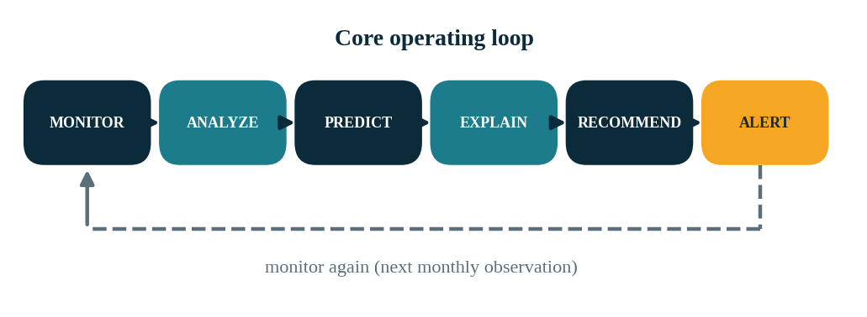
Figure 1.1: The InfraWatch AI operating loop

Illustrative Example (Hypothetical Values, Not Actual Project Data)
This example scenario uses hypothetical values chosen only to explain the intended behaviour of the system; they are not statistics of any actual project. Consider a hypothetical highway construction project with an approved cost of ₹1,000 crore and a revised cost of ₹1,180 crore. Planned physical progress is 60% while actual progress is 45%, and three milestones are delayed. InfraWatch AI computes the cost escalation (18%), the progress gap (15 percentage points) and the milestone delay count, feeds these and related features to the trained models, obtains cost- and time-overrun risk estimates, ranks the contributing factors and generates alerts with suggested review actions.

1.4 Objectives
- Store project master data and monthly monitoring observations in a relational database.
- Compare planned and actual physical and financial progress, and track approved cost, revised cost and expenditure.
- Track milestones and quantify delays.
- Predict cost-overrun risk and schedule-overrun risk and derive a configurable overall 0–100 risk score.
- Explain model output using SHAP and clearly distinguish association from causation.
- Generate configurable, de-duplicated early-warning alerts and suggested interventions for review.
- Compare a feature set of Currently Used Fields (CUF-only) with a CUF plus engineered feature set, and compare a statistical baseline with machine-learning models using real evaluation metrics, to be reported after final model evaluation.
- Provide a grounded AI assistant whose answers are based only on retrieved database facts and ML results.
- Deliver a secure, containerised, demo-ready application.

1.5 Scope and Boundaries
The system is a decision-support tool. It predicts potential risks, provides early warnings, identifies risk factors and supports decision-making. It does not claim to prevent delays, guarantee savings or guarantee project completion. The development and demonstration use synthetic data that is clearly labelled as such; the system is not integrated with any official government monitoring portal, and no claim of official PAIMANA or OCMS integration is made unless an authorised data source or API is actually connected.
Synthetic Data Notice. All data used for development and demonstration is synthetic. It does not represent actual government infrastructure projects, and no result in this document is validated on real government data. There is no official PAIMANA or OCMS integration.

1.6 Significance
Shifting from retrospective reporting to predictive monitoring can give officials more lead time to review resource allocation, procurement status, approvals and critical-path activities. Explainability is treated as a first-class requirement: a risk score that cannot be interrogated is unlikely to be trusted or acted upon in a governance setting. The one-line summary of the project is that InfraWatch AI moves infrastructure project monitoring from descriptive reporting to predictive, explainable and early-warning decision support.

1.7 Organisation of the Report
This document is organised into fourteen chapters, a reference list and two appendices, as summarised in Table 1.1.
Chapter | Content
1–2 | Introduction, problem statement, objectives, scope, and background concepts
3 | Requirements analysis
4–5 | System architecture, technology stack and database design
6–7 | Data, feature engineering and machine-learning methodology
8 | Risk scoring, early warning and recommendations
9–11 | Backend and API design, frontend, and the AI assistant
12 | Testing, deployment and development plan
13 | Evaluation framework and expected outputs
14 | Limitations, ethics, future work and conclusion
References, A–B | References, glossary and configuration reference
Table 1.1: Document organisation

1.8 Document Conventions and Status Labels
To avoid confusion between what the system currently does and what is planned or still to be measured, the following status labels are used throughout the document.
Label | Meaning
Current System | Functionality described as part of the InfraWatch AI system design and implementation in this report
Evaluation | Testing and measurement activities whose final results are to be reported from actual runs
Expected Output | Outputs that the evaluation is designed to produce; no final results are reported in this document
Future Enhancement / Future Work | Planned or possible extensions that are not part of the current system
Table 1.2: Status labels used in this document
Illustrative examples are labelled as such. All data used for development and demonstration is synthetic (Section 1.5).

2. Background and Related Concepts

2.1 Cost and Schedule Overruns in Infrastructure
Cost and schedule overruns in large infrastructure programmes are a well-documented, worldwide phenomenon. Studies of megaprojects, most notably the work of Bent Flyvbjerg and colleagues, report that overruns are common across sectors and geographies and that they arise from a mix of technical, organisational and behavioural causes such as optimism bias, scope changes, procurement issues and land or clearance delays [1]–[3]. These findings motivate a monitoring approach that looks for early warning signs rather than waiting for the final outturn.

2.2 Conventional Monitoring Indicators
Project controllers commonly use a small set of indicators. Schedule variance compares planned and actual progress. Cost variance compares budgeted and actual or revised cost. In earned-value management, the schedule performance index (SPI) and cost performance index (CPI) are ratios of earned value to planned value and to actual cost respectively. InfraWatch AI does not replicate a full earned-value system; it adopts the same intuition through the progress gap, cost growth percentage and expenditure-to-progress ratio [17].

2.3 Machine Learning for Risk Prediction
Supervised learning can capture non-linear relationships between monitoring indicators and eventual outcomes. Four model families are used in this work. Logistic regression is a linear statistical baseline that is easy to interpret [9]. A decision tree partitions the feature space with simple rules and is interpretable but prone to overfitting [8]. Random forest [4] averages many decorrelated trees to reduce variance. XGBoost [5], [23] is a gradient-boosted tree implementation that is widely used for tabular data. Using the same validation protocol for all four avoids assuming that a more complex model is better. Implementations are taken from scikit-learn [7] and XGBoost [5].

2.4 Explainable AI and SHAP
SHAP (SHapley Additive exPlanations; Lundberg and Lee, 2017) [6] attributes a model prediction to its input features using Shapley values from cooperative game theory. For tree-based models an efficient exact algorithm exists [10]; see also the SHAP documentation [22]. SHAP values are model associations: they explain how the model arrived at its output, not why the project is actually at risk in the real world. The system therefore labels SHAP factors as model-derived contributors and avoids causal language [16]. Other post-hoc local explanation methods such as LIME [21] exist, but SHAP is preferred here for its efficient support for tree-based models.

2.5 Large Language Models and Grounding
Large language models are fluent but can fabricate specific values [12]. In a governance context, an invented cost figure or date is unacceptable. InfraWatch AI therefore uses the LLM only for language tasks: explaining, summarising and answering questions. All numbers, dates, names and predictions are retrieved by the backend from MySQL and the ML service and passed to the LLM as context [11]. The assistant labels each statement as FACT, PREDICTION or RECOMMENDATION.

2.6 Gap Addressed by This Work
Many dashboards visualise status but do not predict; many prediction prototypes output a score without explanation or a path to action. InfraWatch AI combines monthly time-series monitoring, a controlled CUF-only versus enhanced feature experiment, a statistical baseline comparison, SHAP explanations, a rule-based early-warning engine and a grounded assistant in one deliberately simple architecture.

3. Requirements Analysis
Status: Current System. The requirements below describe what InfraWatch AI is designed to provide.

3.1 Stakeholders and User Roles
The intended users are officials and analysts who oversee infrastructure portfolios, project managers responsible for individual projects, and system administrators. Four roles are implemented with role-based authorisation.
Role | Description | Typical permissions
ADMIN | System administrator | Full access, user management, project deletion, configuration
PROJECT_MANAGER | Responsible for one or more projects | Create and update projects, monthly data and milestones; resolve alerts
ANALYST | Portfolio analysis and reporting | Read all projects and analytics; upload data; view model performance
VIEWER | Read-only stakeholder | View dashboard, projects, risks, alerts and assistant answers
Table 3.1: User roles and permissions

3.2 Functional Requirements
ID | Requirement
FR-1 | Register, authenticate and authorise users with JWT and role-based access control.
FR-2 | Create, read, update and delete project master records with validation.
FR-3 | Record monthly planned/actual physical and financial progress, expenditure and milestone counts.
FR-4 | Record milestones with planned and actual dates, status and delay days.
FR-5 | Compute cost-overrun, time-overrun and overall risk predictions through the ML service.
FR-6 | Return SHAP-based risk factors for each prediction.
FR-7 | Generate early-warning alerts from configurable rules, without duplicating open alerts.
FR-8 | Generate suggested actions for review linked to risk factors.
FR-9 | Provide dashboard KPIs, distributions and trends by sector, ministry and agency.
FR-10 | Support search, filtering, sorting and pagination of projects and alerts.
FR-11 | Support validated CSV/Excel upload of monitoring data.
FR-12 | Display actual model comparison metrics from the ML service.
FR-13 | Provide a grounded assistant for natural-language project questions.
Table 3.2: Functional requirements

3.3 Non-Functional Requirements
Category | Requirement
Security | BCrypt password hashing, JWT validation, protected endpoints, CORS restriction, no secrets in source control.
Reliability | Graceful behaviour when the ML service, database or LLM is unavailable; clear error responses.
Explainability | Every risk score is accompanied by ranked factors; association is not presented as causation.
Integrity | No fabricated metrics or project values; synthetic data labelled as synthetic.
Usability | Responsive interface with loading, empty and error states; consistent risk colour coding.
Maintainability | Layered architecture, DTOs, centralised exception handling, environment-based configuration.
Portability | Docker and Docker Compose for repeatable local and deployment environments.
Performance | Paginated queries, indexed columns, and model loading at service start-up rather than per request.
Table 3.3: Non-functional requirements

3.4 Representative Use Cases
- Portfolio review. An analyst opens the dashboard, inspects the risk distribution and drills into high-risk projects in a chosen ministry.
- Project deep dive. A manager opens a project, reviews monthly progress against plan, reads the SHAP factors and the suggested actions, and resolves an alert after review.
- Data update. An authorised user uploads the latest monthly observations; the system validates the file, stores the data and refreshes predictions and alerts.
- Question answering. A viewer asks the assistant why a project is high risk and receives an answer that separates facts, predictions and recommendations.

4. System Architecture and Design
Status: Current System. This chapter describes the architecture and components of InfraWatch AI.

4.1 Architectural Overview
InfraWatch AI uses a three-tier architecture with one additional specialised service. The React frontend communicates with the Spring Boot backend through REST and JSON (framework documentation is listed in [19]). The backend owns authentication, authorisation, validation and business logic, persists data in MySQL through JPA/Hibernate and calls the Python FastAPI ML service for predictions and explanations. For the assistant, the backend retrieves grounded context and calls the LLM. The design intentionally avoids additional microservices: a single API gateway and a single ML service keep the system understandable and demonstrable.
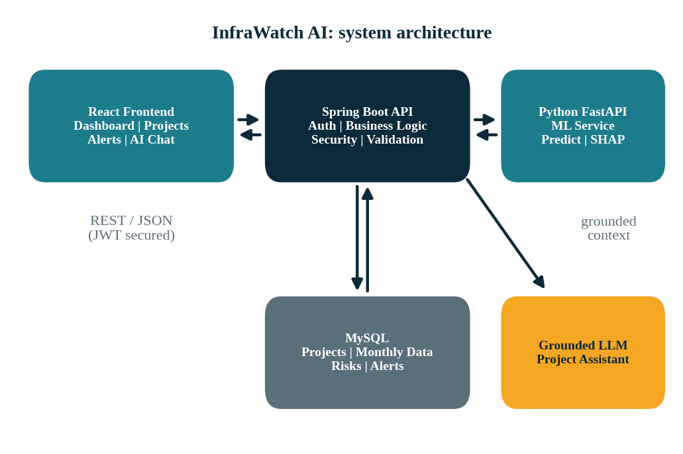
Figure 4.1: High-level system architecture

4.2 Technology Stack and Rationale
Layer | Technology | Purpose and rationale
Frontend | React, Vite, JavaScript, React Router, Axios | Component-based SPA with fast builds and routing
UI and charts | Tailwind CSS, Recharts, shadcn/ui | Professional dashboard, responsive layout and charts
Backend | Java, Spring Boot, Maven | Mature, production-style REST framework
Security | Spring Security, JWT, BCrypt | Stateless authentication and role-based authorisation
Persistence | MySQL, Hibernate/JPA | Relational integrity for projects, monthly data and alerts
ML service | Python, FastAPI | Lightweight, typed model-serving API
ML libraries | Scikit-learn, XGBoost, Pandas, NumPy | Baselines, tree ensembles, preprocessing and features
Explainability | SHAP | Feature attribution for tree-based and linear models
Model storage | Joblib | Serialisation of trained pipelines
Assistant | Grounded LLM | Natural-language explanation over retrieved facts
DevOps | Docker, Docker Compose, Git | Repeatable environments and version control
Table 4.1: Technology stack and rationale

4.3 Backend Package Structure
The backend follows a layered structure under the base package com.infrawatch: controller (REST endpoints), service (business logic), repository (Spring Data JPA), entity (persistent model), dto (request and response objects), security (JWT filter, user details, role configuration), exception (centralised @RestControllerAdvice handling), config (CORS, OpenAPI, properties) and client (HTTP client to the ML service and LLM). Entities are never exposed directly; DTOs decouple the API contract from the schema.

4.4 ML Service Structure
The ML service is organised into api (FastAPI routers), models (persisted model artefacts and metadata), services (prediction orchestration), preprocessing (cleaning, encoding, feature engineering), explainability (SHAP), recommendations (rule mapping) and schemas (Pydantic request and response models). Trained models are saved with Joblib together with a model-version record and loaded once at start-up.

4.5 Frontend Structure
The frontend is organised into components (reusable UI and chart components), pages, services (Axios API modules), hooks, context (authentication state), utils and routes (protected routing). An Axios interceptor attaches the JWT to each request and handles expiry and unauthorised responses.

4.6 Key Interaction: Refreshing a Project Assessment
When monthly data is added or updated, the backend (1) validates and stores the observation, (2) assembles the feature vector from the project master record, the monthly history and the milestones, (3) calls the ML service for cost, time and overall risk predictions and SHAP factors, (4) stores the prediction and risk factors, (5) evaluates the alert rules and creates or updates alerts, and (6) generates or refreshes recommendations. The frontend then reads the updated state through the risk, alert and recommendation endpoints.

4.7 Configuration and Secrets
All environment-specific values, including database credentials, the JWT signing secret, the ML service URL, the LLM endpoint and API key, and allowed CORS origins, are supplied through environment variables. A .env.example file documents the variables without real values, and .gitignore rules prevent committing secrets.

5. Database Design
Status: Current System. This chapter describes the relational schema used by the system. Seed data is synthetic.

5.1 Design Principles
The MySQL schema uses surrogate primary keys, foreign keys with explicit relationships, unique constraints on natural keys such as the project code, check constraints for percentage fields, indexes on frequently filtered columns and created/updated timestamps on all mutable tables. Ministries, sectors and agencies are normalised into separate tables to support portfolio-level comparison.
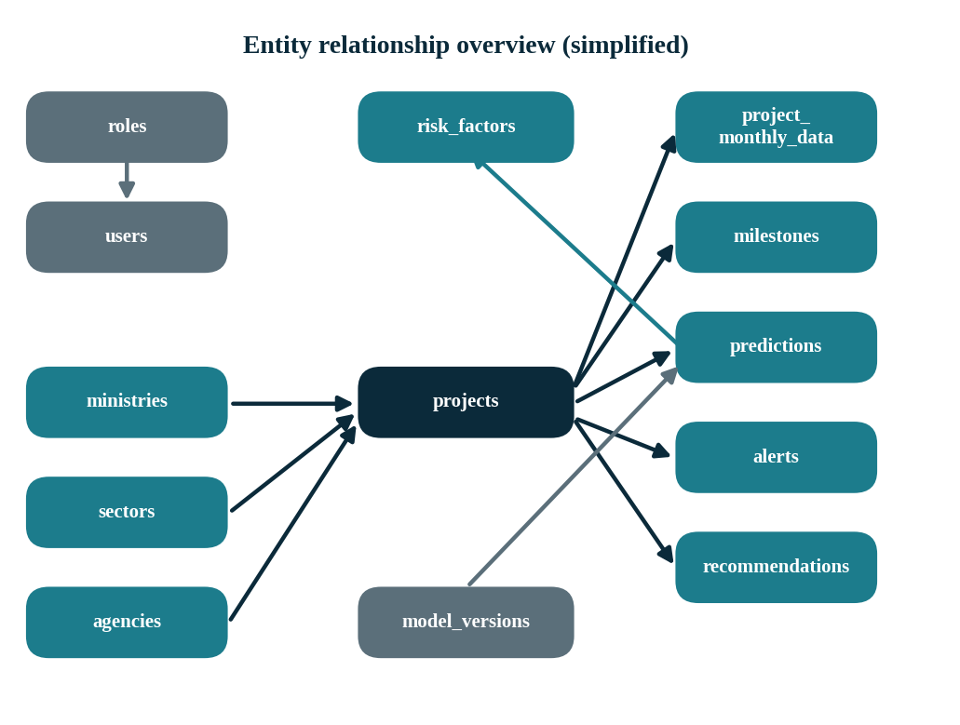
Figure 5.1: Entity relationship overview

5.2 Tables and Their Purpose
Table | Main purpose
roles, users | Authentication and authorisation
ministries, sectors, agencies | Project classification and organisational structure
projects | Project master information
project_monthly_data | Monthly planned/actual progress and financial observations
milestones | Milestone dates, completion and delay information
predictions | ML prediction and risk score history
risk_factors | SHAP and explanation factors per prediction
alerts | Early-warning alerts and resolution state
recommendations | Suggested actions for review
model_versions | Model versions with actual evaluation metrics (JSON)
Table 5.1: Database tables and their purposes

5.3 Core Table Definitions

projects
Stores project code (unique), name, foreign keys to ministry, sector and implementing agency, state, district, approved cost, revised cost, current expenditure, approval date, original start date, original completion date, revised completion date, physical progress, financial progress and status.

project_monthly_data
Stores one observation per project per reporting month (unique on project and month): planned and actual physical progress, planned and actual financial progress, monthly and cumulative expenditure, milestones planned, completed and delayed, revised cost and revised completion date.

milestones
Stores milestone name, description, planned date, actual date, status and delay days. Delay days are derived from planned and actual dates (or the current date for overdue milestones).

predictions, risk_factors and model_versions
A prediction row stores the prediction date, cost-overrun probability, predicted cost-overrun percentage, time-overrun probability, predicted delay in months, overall risk score, risk level and a model-version reference. Each prediction has zero or more risk-factor rows (factor name, impact value, direction, description). The model_versions table stores model name, type, version, training date, dataset version and a JSON document of the actual evaluation metrics.

alerts and recommendations
Alerts store type, severity, title, description, trigger value, threshold value, suggested action, resolved status and timestamps. Recommendations store the associated risk factor, the recommendation text, a priority and a source (for example rule-based).

5.4 Monthly Monitoring Data
Monthly data allows the system to understand how a project changes over time, not just where it stands. For example, planned progress of 20%, 30% and 40% in three consecutive months, against actual progress of 18%, 25% and 31%, reveals a progress gap that widens from 2 to 5 to 9 percentage points. The system can therefore detect an increasing gap, slowing progress, expenditure/progress mismatch, milestone delays and rising risk.

5.5 Indexing and Integrity
- Unique index on projects.project_code and on (project_id, reporting_month) in monthly data.
- Indexes on projects (ministry, sector, agency, status) for filtering, and on predictions (project_id, prediction_date) for latest-prediction lookups.
- Index on alerts (project_id, alert_type, resolved) to support de-duplication checks.
- Foreign keys with appropriate delete behaviour; percentage columns constrained to 0–100.

5.6 Seed Data
Realistic synthetic seed data supports development and demonstration. It includes low-, medium- and high-risk projects with cost escalation, delayed milestones, progress gaps and expenditure/progress mismatch, and enough monthly observations to show trends. It is labelled synthetic in the database documentation and user interface and is never presented as official data.

6. Data and Feature Engineering
Status: Current System. The development dataset is synthetic (Section 6.1); no real government data is used.

6.1 Data Sources
During development, the ML dataset is generated from the synthetic seed data with controlled randomness, so that relationships between indicators and outcomes are plausible but not derived from any real project. The dataset is versioned, and the dataset version is recorded in the model_versions table. If authorised real data becomes available, the same pipeline can be retrained on it and the results re-evaluated from scratch. Experiments on the synthetic dataset demonstrate that the pipeline works; they are not validated on real government data and do not describe the performance of any actual infrastructure project.

6.2 Prediction Targets
- Cost-overrun target: a binary label indicating whether the project’s eventual cost overrun exceeds a configurable threshold, together with a regression target for the overrun percentage, calculated as ((revised cost − approved cost) / approved cost) × 100.
- Time-overrun target: a binary label indicating whether the eventual completion date exceeds the original by more than a configurable margin, together with a regression target for delay in months.
- Overall risk: a configurable 0–100 score derived from model outputs and rule-based indicators (Chapter 8).
The thresholds used to define the labels are configurable assumptions of the development dataset and are not presented as official definitions.

6.3 Experiment A: CUF-Only Features
Experiment A uses only the Currently Used Fields (CUF), that is, the fields that are currently used and available in CUF-style project records: sector, ministry and agency identifiers, state, approved cost, revised cost, current expenditure, original and revised completion dates, physical progress, financial progress and status. This experiment represents what could be done with the data as it exists today. The A/B comparison is intended to compare the two feature sets and the four model families under the same validation approach; it does not by itself establish that any feature set or model is superior.

6.4 Experiment B: CUF Plus Engineered Features
Experiment B adds engineered variables that capture progress dynamics, cost dynamics and schedule pressure. The engineered features are summarised below.
Feature | Definition / intuition
Progress gap | Planned physical progress − actual physical progress
Cost growth % | (Revised cost − approved cost) / approved cost × 100
Expenditure/progress ratio | Financial (or expenditure) progress relative to physical progress; high values with low physical progress signal mismatch
Monthly progress change | Change in actual progress versus the previous month
Milestone delay rate | Delayed milestones / planned milestones
Delayed milestone count | Number of milestones past their planned date without completion
Elapsed duration | Time since original start date relative to planned duration
Remaining duration | Time between the observation date and the (revised) completion date
Historical progress trend | Slope of actual progress over recent months
Expenditure trend | Slope of cumulative expenditure over recent months
Schedule extension indicator | Revised completion date later than original, and by how much
Table 6.1: Engineered features (Experiment B)

6.5 Data Quality Handling
- Missing values: imputed with strategies appropriate to the variable (for example median for numeric fields), with missingness indicators where informative.
- Invalid values: progress outside 0–100, negative costs, completion dates before start dates and similar records are rejected or flagged during validation.
- Categorical encoding: one-hot or ordinal encoding chosen per model family; high-cardinality identifiers are handled carefully to avoid overfitting.
- Scaling: standardisation for logistic regression; tree-based models do not require scaling.
- Class imbalance: class weights or resampling applied on training data only, and evaluated with precision, recall, F1 and ROC-AUC rather than accuracy alone [15].

6.6 Preventing Data Leakage
A central rule is that only information available at the prediction date may be used as a feature. For monthly data, each training row represents a project at a given month and uses only observations up to and including that month. Splitting is chronological (train on earlier periods, validate and test on later ones) [13], and rows from the same project are not allowed to leak future information into earlier splits. Features that directly encode the final outcome, such as a final revised cost that is only known at completion, are excluded from the leakage-prone experiments. This discipline is what makes the reported metrics a fair estimate of real early-warning performance [14].

7. Machine Learning Methodology
Status: Current System (methodology). Evaluation results are to be updated after final model evaluation (Chapter 13).

7.1 Overall Pipeline
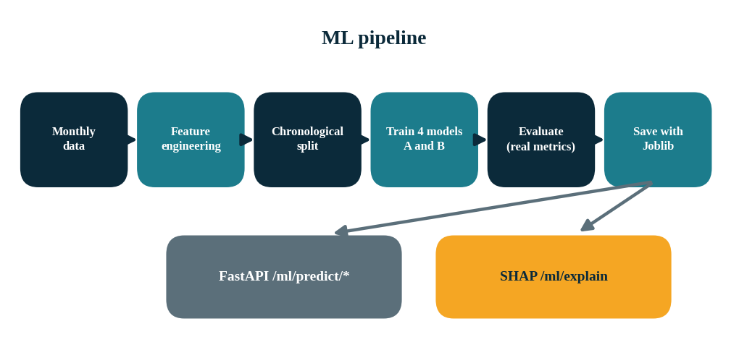
Figure 7.1: Machine-learning pipeline and serving

7.2 Models Compared
Model | Role | Notes
Logistic Regression | Statistical baseline | Requires scaling; coefficients are directly interpretable
Decision Tree | Interpretable non-linear model | Depth constrained to limit overfitting
Random Forest | Ensemble of trees | Robust to noise; feature importance available
XGBoost | Gradient-boosted trees | Strong tabular performance; tuned on validation data only
Table 7.1: Models compared
Each model is trained for the cost-overrun and time-overrun classification tasks and, where regression targets are used, a corresponding regressor is trained. Every model is trained under both Experiment A and Experiment B, giving a controlled comparison in which the only difference between paired runs is the feature set.

7.3 Validation Protocol
- Chronological train, validation and test partitions; the test partition is used only once for final reporting [13].
- Hyperparameters tuned on the validation partition, or with time-series-aware cross-validation, never on the test partition.
- Preprocessing steps (imputation, scaling, encoding) fitted on the training partition only and applied to the others.
- Identical splits used for all models and both experiments to ensure comparability.

7.4 Evaluation Metrics
Task | Metrics | Interpretation
Classification | Accuracy, Precision, Recall, F1, ROC-AUC | Recall matters for early warning (missed at-risk projects); precision controls alert fatigue
Regression | MAE, RMSE, R² | Error in predicted overrun percentage and delay months
Table 7.2: Evaluation metrics
No performance figure is invented. All metrics are produced by running the evaluation code on the development dataset and are stored as JSON in model_versions. The Model Performance page reads these values from the ML service; nothing is hard-coded. Evaluation status: results to be updated after final model evaluation.

7.5 Model Selection
The best model is selected only after the actual results have been produced, using a stated criterion (for example ROC-AUC and recall on the validation data, with the test data held back for confirmation). Differences between models are interpreted with caution because the development dataset is synthetic; a model that performs well on synthetic data has demonstrated that the pipeline works, not that it will generalise to real projects. This document does not claim that any model is best.

7.6 Explainability with SHAP
For supported models the ML service computes SHAP values for each prediction and returns the top contributing factors with their impact value and direction (increasing or decreasing risk). Technical feature names are mapped to plain-language factors such as low physical progress, milestone delays, cost escalation, expenditure/progress mismatch, schedule pressure and historical deterioration. Every explanation carries a statement that the factors describe how the model reached its output and do not prove causation. In other words, SHAP identifies features that contributed to the model prediction; these are model-derived contributors, and they do not show that any real-world factor (for example, a contractor delay) caused the project risk.

7.7 Model Serving and Versioning
Trained pipelines are serialised with Joblib and loaded when the FastAPI service starts. Each prediction response includes the model version, and a model-version record stores the model type, training date, dataset version and metrics. The service exposes the following endpoints.
Endpoint | Purpose
GET /health | Service and model-loading status
POST /ml/predict/cost | Cost-overrun probability and predicted overrun percentage
POST /ml/predict/time | Time-overrun probability and predicted delay in months
POST /ml/predict/risk | Combined overall risk score and risk level
POST /ml/explain | SHAP-based top risk factors for a project
Table 7.3: ML service endpoints

8. Risk Scoring, Early Warning and Recommendations
Status: Current System. Thresholds in this chapter are illustrative, configurable defaults and not official standards.

8.1 Overall Risk Score
Cost-overrun risk and time (schedule) overrun risk are predicted separately; the overall project risk score is a configurable value from 0 to 100 that combines these model outputs with relevant rule-based indicators. A simple, transparent formulation is a weighted combination of the cost-overrun probability, the time-overrun probability and an indicator-severity component, scaled to 0–100. The weights and the risk-level cut-offs are configuration values; the illustrative default interpretation is 0–30 LOW, 31–60 MEDIUM and 61–100 HIGH. These thresholds are illustrative and configurable; they are not official government standards and can be changed without code changes.
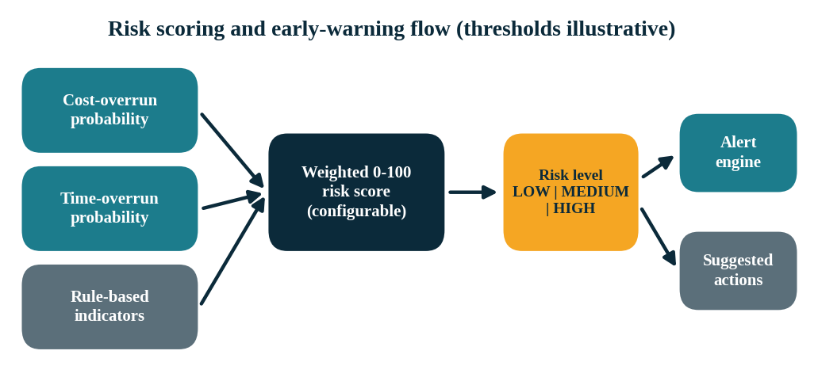
Figure 8.1: Risk scoring and early-warning flow

8.2 Early-Warning Rules
The alert engine evaluates the rules below after each data update or prediction refresh. Thresholds are configurable and no official threshold is assumed; the values in the configuration are illustrative development defaults.
Rule | Condition | Signal
Progress gap | Planned physical progress significantly exceeds actual progress | Project is behind plan
Progress deterioration | Month-over-month actual progress is worsening | Slowing execution
Cost escalation | ((revised − approved) / approved) × 100 above threshold | Budget pressure
Expenditure/progress mismatch | High expenditure combined with low physical progress | Value-for-money concern
Milestone delay | Planned milestone date passed without completion | Critical-path risk
Schedule risk | Remaining duration insufficient for remaining work | Completion date at risk
Risk escalation | Overall risk score rises significantly versus previous prediction | Deteriorating outlook
High-risk project | Overall risk crosses the configured high-risk threshold | Priority for review
Table 8.1: Early-warning rules

8.3 Severity Levels
Severity | Meaning | Display colour
LOW | Minor deviation; monitor | Green
MEDIUM | Noticeable deviation; review at next cycle | Amber
HIGH | Significant deviation; prompt review recommended | Red
CRITICAL | Severe deviation or multiple concurrent signals; urgent review recommended | Dark red
Table 8.2: Alert severity levels
Severity mapping is configurable per rule, for example by defining a threshold at which a rule moves from MEDIUM to HIGH.

8.4 Duplicate Prevention
Alerts must not be regenerated on every run. Before creating an alert, the engine looks for an existing unresolved alert with the same project and alert type. If one exists, it updates the trigger value, and escalates the severity if the condition has worsened, instead of inserting a new row. A new alert is created only if no open alert of that type exists, for example after the previous one has been resolved and the condition has recurred. Each alert stores its trigger value and threshold so that it remains auditable.

8.5 Recommendation Engine
The recommendation engine converts risk factors into suggested actions for review. The wording is deliberately cautious: “Suggested action”, “Potential intervention” and “Review recommended”. Recommendations are not guaranteed solutions and the system never claims that following them will prevent a delay. Each item in the table below may be reviewed by the project team; none should be read as a guaranteed remedy. Recommendation records are stored in MySQL with the associated risk factor, priority and source, and are exposed through the API and the dashboard.
Risk factor | Suggested actions for review
Low physical progress | Review resource allocation; review equipment availability; review critical-path activities; inspect work-package bottlenecks
Milestone delays | Review delayed dependencies; review pending approvals; review contractor and work-package status; assess critical-path impact
High expenditure with low progress | Investigate expenditure/progress mismatch; review procurement and contract status; analyse major cost drivers
Cost risk | Review cost escalation drivers; inspect procurement and contract variations; compare original and revised cost
Schedule risk | Review critical path; review remaining activities; assess resource allocation; review dependencies
Table 8.3: Risk factors and suggested actions for review

9. Backend, Security and API Design
Status: Current System. This chapter describes the backend services and REST API.

9.1 API Conventions
All endpoints are versioned under /api/v1, exchange JSON, use DTOs, apply Bean Validation and return consistent error responses with proper HTTP status codes (400 validation, 401 unauthenticated, 403 unauthorised, 404 not found, 409 conflict, 503 dependency unavailable). Collection endpoints support pagination, sorting, filtering by ministry, sector, status and risk level, and search by project name or code.

9.2 Endpoint Catalogue
Group | Endpoints
Authentication | POST /auth/register, /auth/login, /auth/refresh, /auth/logout
Projects | GET /projects, GET /projects/{id}, POST /projects, PUT /projects/{id}, DELETE /projects/{id}
Monthly data | GET and POST /projects/{id}/monthly-data, PUT /projects/{id}/monthly-data/{monthlyDataId}
Milestones | GET and POST /projects/{id}/milestones, PUT /milestones/{id}
Dashboard | GET /dashboard/summary, /risk-distribution, /projects-by-sector, /projects-by-ministry, /cost-trends, /delay-trends
Risk | GET /projects/{id}/risk, /projects/{id}/risk-factors, /projects/{id}/recommendations
Alerts | GET /alerts, GET /alerts/{id}, PATCH /alerts/{id}/resolve
Assistant | POST /assistant/chat
Table 9.1: REST API endpoint catalogue

9.3 Authentication and Authorisation
Passwords are hashed with BCrypt, following current password-storage guidance [24], and never stored or logged in clear text. On login the server issues a short-lived JSON Web Token (JWT) access token [18] and a refresh token. A security filter validates the token signature and expiry on each request and populates the security context with the user’s role. Method-level and route-level rules restrict write operations to ADMIN and PROJECT_MANAGER, data upload to ADMIN, PROJECT_MANAGER and ANALYST, and leave read-only access to VIEWER. Logout invalidates the refresh token. CORS is limited to configured frontend origins.

9.4 ML Client Layer
A dedicated client in the client package wraps calls to the FastAPI service, with timeouts, error mapping and retry limits. If the ML service is unavailable, the backend returns a clear 503 response for prediction-dependent endpoints while continuing to serve data that does not require ML. No fake ML results are generated: a missing prediction is reported as missing.

9.5 Error Handling
A @RestControllerAdvice class maps validation errors, missing resources, access-denied conditions, database errors and downstream service failures to a uniform error body (timestamp, status, error code, message, request path); stack traces are never returned to clients.

9.6 Data Upload Validation
CSV and Excel uploads are validated before any database write (required columns, data types, value ranges, unknown project codes, duplicate project-month rows and inconsistent dates), with row-level feedback to the user. Only valid rows are persisted, after which predictions and alerts are refreshed for the affected projects.

10. Frontend and User Experience
Status: Current System. This chapter describes the user interface of the platform.

10.1 Design Approach
The interface is designed to resemble a professional analytics platform rather than a simple CRUD site. Its information architecture mirrors the system’s logic: monitor, predict, explain, recommend and alert. Risk levels use a consistent colour language: LOW is green, MEDIUM is amber and HIGH and CRITICAL are red.

10.2 Pages
Page | Content
Login | JWT-based authentication with error feedback
Dashboard | KPI cards; risk distribution, projects by sector and ministry, cost, delay and risk trends; high-risk project table
Projects | Search, filters (risk, ministry, sector, status), sorting and pagination
Project Details | Master data, costs, progress, milestones, predictions, risk factors, SHAP explanation, suggested actions, alerts, monthly progress and expenditure charts, risk history
Risk Analytics | Comparative analysis across sectors, ministries and agencies
Alerts | Alert list with severity, filters and resolve action
Data Upload | Validated CSV/Excel upload with feedback
Model Performance | Real metrics for the four models and both experiments
AI Recommendations | Consolidated suggested actions for review
AI Assistant | Grounded chat with supporting risk score, factors, alerts and recommendations
Table 10.1: Frontend pages

10.3 Dashboard Content
The dashboard presents KPI cards for total projects, high-, medium- and low-risk counts, approved cost, revised cost and total expenditure. Charts show risk distribution, projects by sector and ministry, cost trend, delay trend and risk trend. A high-risk table lists project code, name, ministry, sector, risk score, risk level, key risk factor and alert status, allowing officials to move from portfolio overview to a specific project in one click.

10.4 Robustness
- Loading, empty and error states on every data-driven component.
- Axios interceptors for token attachment, expiry handling and redirect to login on 401.
- Route guards and role-aware UI elements for unauthorised access.
- Responsive layout for desktop and tablet screens.
- Reusable components for KPI cards, risk badges, charts and tables.
- A visible “synthetic demo data” label wherever demo data is displayed.

11. AI Project Intelligence Assistant
Status: Current System. The assistant explains retrieved facts and ML results; it is not a prediction model.

11.1 Role Separation
Machine learning is responsible for cost-risk prediction, time-risk prediction, overall risk scoring and SHAP explanations. The LLM is not used as a numerical prediction model. Its responsibilities are limited to explaining project information, summarising risk, answering natural-language questions, explaining ML results in simple language and summarising recommendations. Project-specific numbers, dates and predictions shown by the assistant come from the retrieved project and ML context; the LLM does not generate them.

11.2 Grounding Architecture
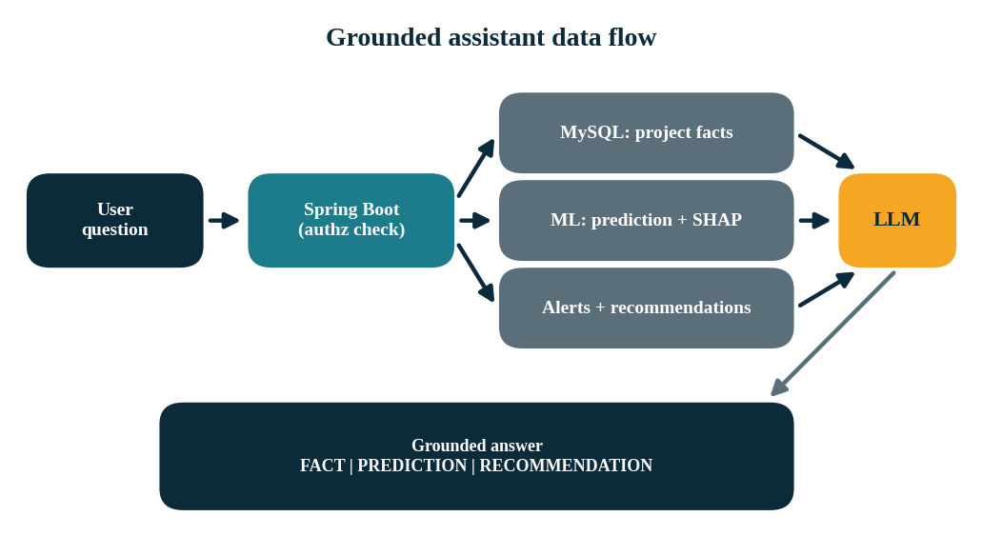
Figure 11.1: Grounded assistant data flow
The endpoint POST /api/v1/assistant/chat receives a message and an optional project identifier. After checking that the user is authorised to see the project, the backend retrieves project facts, current progress, approved and revised cost, expenditure, milestones, the latest prediction, risk score and level, SHAP factors, alerts and recommendations, and passes this context to the LLM with instructions to answer only from it.

11.3 FACT, PREDICTION and RECOMMENDATION
Every substantive statement is labelled. FACT denotes information retrieved directly from the database. PREDICTION denotes output of the ML model. RECOMMENDATION denotes a suggested decision-support action.

11.4 Hallucination and Data-Validation Safeguards
- The LLM is instructed not to invent project costs, progress values, dates, risk scores, ministry names, sector information, milestones or model metrics; if information is unavailable, the assistant says so [11], [12].
- Numeric values in the response can be cross-checked against the retrieved context before display.
- Cross-project questions retrieve only the necessary data that the user is authorised to access.
- System prompts and internal implementation details are not exposed.
- Explicit handling of LLM unavailable, invalid project, unauthorised access, missing prediction and missing data cases.

11.5 Supported Questions
Examples include: why a project is high risk; the main risk factors; what caused the risk score to increase; the predicted cost-overrun risk; delayed milestones; what the project team should review; progress against plan; and a summary of current status.

12. Testing, Deployment and Development Plan
Status: Current System / Evaluation / Future Work. Section 12.1 (test strategy) is labelled Evaluation; Section 12.5 (deployment notes) is labelled Future Work.

12.1 Test Strategy
Area | What is verified
Frontend | Login, dashboard, project list and details, analytics, alerts, recommendations, model performance, upload, assistant; loading, empty and error states; responsive behaviour
Backend | Authentication, JWT, role-based authorisation, project, monthly-data, milestone, dashboard, risk, alert, recommendation and assistant APIs; validation and error responses
ML | Preprocessing, both feature experiments, training, evaluation, prediction, SHAP, model serialisation and FastAPI endpoints
Database | Relationships, constraints, indexes, seed data and query correctness
Integration | React to Spring Boot, Spring Boot to MySQL, to the ML service and to the LLM service
Security | Password hashing, JWT validation, protected endpoints, CORS, environment variables, no secrets in Git
Error handling | Invalid requests, missing resources, unauthorised access, ML unavailable, database errors, LLM unavailable, frontend API failures
Table 12.1: Test strategy
Evaluation. Alert-engine tests specifically cover rule triggering, alert creation, duplicate prevention, recommendation creation, alert resolution and project risk retrieval. Test results are reported from actual runs.

12.2 Containerisation
Service | Container | Notes
frontend | React build served by a lightweight web server | API base URL from environment
backend | Spring Boot application | Database, JWT, ML and LLM settings from environment
ml-service | FastAPI with model artefacts | Loads models at start-up; exposes /health
mysql | MySQL database | Persistent volume; initialised with schema and seed scripts
Table 12.2: Container services
Docker Compose starts all four services with a single command. Passwords and API keys are supplied through environment variables, and .env.example files document the required values.

12.3 Phased Development Plan
The project is built in eight sequential phases, each implemented and tested before the next begins.
Phase | Build | Main result
1 | Architecture and setup | Frontend, backend and ML project skeleton with health endpoints
2 | MySQL database | Schema and realistic synthetic demo data
3 | Spring Boot backend | REST APIs, JWT and roles
4 | ML and SHAP | Predictions, CUF experiment and model comparison
5 | Alerts and recommendations | Early warnings and suggested actions
6 | React frontend | Dashboard, project analytics and UI
7 | AI assistant | Grounded project-intelligence chat
8 | Testing and Docker | Integrated, demo-ready application
Table 12.3: Phased development plan

12.4 Demonstration Flow
A reliable demonstration follows eleven steps: log in; open the dashboard; view the risk distribution; open a high-risk project; show the monthly progress trend; show the cost and time predictions; show SHAP risk factors; show early-warning alerts; show suggested actions; ask the assistant why the project is high risk; and show the model comparison results.

12.5 Deployment Notes
Future Work. For a real deployment the following are recommended: managed MySQL with backups; TLS termination and secure secret management; restricted CORS origins; monitoring and logging for all services; a model-retraining and versioning process; and an approved data-ingestion pathway from an authorised source. Before any operational use, the models must be re-evaluated on real data.

13. Evaluation Framework and Expected Outputs
Status: Evaluation / Expected Output. No final evaluation results are reported in this document.
This chapter defines how the results will be reported. The tables are templates to be filled only with outputs of the evaluation code; no values are pre-filled and metrics are never invented. Results to be updated after final model evaluation.

13.1 Classification Comparison (Cost-Overrun Target)
Model | Features | Accuracy | Precision | Recall | F1 | ROC-AUC
Logistic Regression | A: CUF-only | — | — | — | — | —
Logistic Regression | B: CUF + engineered | — | — | — | — | —
Decision Tree | A: CUF-only | — | — | — | — | —
Decision Tree | B: CUF + engineered | — | — | — | — | —
Random Forest | A: CUF-only | — | — | — | — | —
Random Forest | B: CUF + engineered | — | — | — | — | —
XGBoost | A: CUF-only | — | — | — | — | —
XGBoost | B: CUF + engineered | — | — | — | — | —
Table 13.1: Classification comparison template, cost-overrun target (values to be updated)

13.2 Regression Comparison (Overrun Percentage / Delay Months)
Model | Features | MAE | RMSE | R²
Best baseline and ML models | A: CUF-only | — | — | —
Best baseline and ML models | B: CUF + engineered | — | — | —
Table 13.2: Regression comparison template (values to be updated)
The same tables are repeated for the time-overrun target. Values are to be populated from the model_versions metrics after final model evaluation; none are reported here.

13.3 How Results Will Be Interpreted
- Feature experiment: improvements of Experiment B over Experiment A indicate the added value of engineered progress, cost and schedule indicators.
- Baseline comparison: gains of the tree-based models over logistic regression indicate the value of non-linear modelling.
- Recall versus precision: the operating point is chosen with the alert workload in mind.
- Explainability check: SHAP factors should match domain expectations (for example, a larger progress gap increases risk); unexpected patterns are investigated.
- Caveat: results on synthetic data validate the pipeline, not real-world accuracy.

13.4 Quality Checklist Before Demonstration
Before demonstration the following are checked: no console errors or broken imports; API URL and CORS correctly configured; database connection and Docker services verified; authentication and all major screens verified; no fake model metrics displayed; synthetic data clearly labelled; and no claim of official PAIMANA or OCMS integration.

14. Limitations, Ethics, Future Work and Conclusion
Status: Current System limitations / Future Enhancement. Section 14.3 lists Future Enhancements.

14.1 Limitations
- Synthetic data: the development and demonstration dataset is synthetic; generalisation to real projects is untested.
- No official integration: there is no official PAIMANA or OCMS integration; the system is not connected to any government portal or government API, and ingestion is by upload or seed data.
- Prediction uncertainty: predictions are probabilistic estimates; they can be wrong and must not replace professional judgement.
- Association not causation: SHAP factors describe model behaviour, not true causes.
- Configurable thresholds: illustrative; they need calibration with domain experts.
- Rule-based recommendations: suggestions are generic and ignore project-specific conditions.
- LLM dependence: the assistant depends on an external model; grounding reduces but cannot fully eliminate errors.

14.2 Ethical and Governance Considerations
Because the outputs may influence decisions about public projects, transparency is essential. Users are told that scores are estimates, that recommendations are for review and that data may be synthetic. Risk scores should not be used as the sole basis for penalising individuals or agencies; they are prompts for review. Model versions and data versions are recorded so that any output can be traced back to how it was produced.

14.3 Future Enhancements
Future Enhancement / Future Work. These extensions are not part of the current system.
- Integration with authorised real monitoring data sources and automated ingestion.
- Model retraining pipelines, drift monitoring and calibration of probabilities.
- Survival or time-series models for delay forecasting, and quantified uncertainty intervals.
- Notification channels (email, SMS) for alert delivery and escalation workflows.
- Geospatial views and contractor- or work-package-level analysis.
- Audit logs, approval workflows, multilingual assistant support and scenario analysis of risk sensitivity.

14.4 Conclusion
InfraWatch AI demonstrates how an integrated architecture of a React dashboard, a Spring Boot API, a MySQL store, a Python ML service with SHAP explanations, a rule-based early-warning engine and a grounded assistant can turn monthly monitoring data into predictive, explainable decision support for infrastructure projects. The design emphasises honesty about what the system can and cannot claim: metrics come from real evaluation, synthetic data is labelled, recommendations are suggestions for review, and the LLM never invents numbers. Following the eight-phase plan yields a demo-ready application. Final evaluation results are to be updated after final model evaluation, and evaluation on authorised real data remains Future Work.

References
[1] Flyvbjerg, B., Holm, M. S. and Buhl, S. (2002). Underestimating Costs in Public Works Projects: Error or Lie? Journal of the American Planning Association, 68(3), 279–295. https://doi.org/10.1080/01944360208976273
[2] Flyvbjerg, B. (2014). What You Should Know About Megaprojects and Why: An Overview. Project Management Journal, 45(2), 6–19. https://doi.org/10.1002/pmj.21409
[3] Flyvbjerg, B. (2009). Survival of the Unfittest: Why the Worst Infrastructure Gets Built, and What We Can Do About It. Oxford Review of Economic Policy, 25(3), 344–367. https://doi.org/10.1093/oxrep/grp024
[4] Breiman, L. (2001). Random Forests. Machine Learning, 45(1), 5–32. https://doi.org/10.1023/A:1010933404324
[5] Chen, T. and Guestrin, C. (2016). XGBoost: A Scalable Tree Boosting System. Proceedings of the 22nd ACM SIGKDD International Conference on Knowledge Discovery and Data Mining, 785–794. https://doi.org/10.1145/2939672.2939785
[6] Lundberg, S. M. and Lee, S.-I. (2017). A Unified Approach to Interpreting Model Predictions. Advances in Neural Information Processing Systems 30, 4765–4774. https://arxiv.org/abs/1705.07874
[7] Pedregosa, F. et al. (2011). Scikit-learn: Machine Learning in Python. Journal of Machine Learning Research, 12, 2825–2830. https://jmlr.org/papers/v12/pedregosa11a.html
[8] Quinlan, J. R. (1986). Induction of Decision Trees. Machine Learning, 1(1), 81–106. https://doi.org/10.1007/BF00116251
[9] Hosmer, D. W., Lemeshow, S. and Sturdivant, R. X. (2013). Applied Logistic Regression, 3rd ed. Wiley. https://doi.org/10.1002/9781118548387
[10] Lundberg, S. M. et al. (2020). From Local Explanations to Global Understanding with Explainable AI for Trees. Nature Machine Intelligence, 2(1), 56–67. https://doi.org/10.1038/s42256-019-0138-9
[11] Lewis, P. et al. (2020). Retrieval-Augmented Generation for Knowledge-Intensive NLP Tasks. Advances in Neural Information Processing Systems 33, 9459–9474. https://arxiv.org/abs/2005.11401
[12] Ji, Z. et al. (2023). Survey of Hallucination in Natural Language Generation. ACM Computing Surveys, 55(12), Article 248. https://doi.org/10.1145/3571730
[13] Bergmeir, C. and Benítez, J. M. (2012). On the Use of Cross-Validation for Time Series Predictor Evaluation. Information Sciences, 191, 192–213. https://doi.org/10.1016/j.ins.2011.12.028
[14] Kaufman, S., Rosset, S., Perlich, C. and Stitelman, O. (2012). Leakage in Data Mining: Formulation, Detection, and Avoidance. ACM Transactions on Knowledge Discovery from Data, 6(4), Article 15. https://doi.org/10.1145/2382577.2382579
[15] Fawcett, T. (2006). An Introduction to ROC Analysis. Pattern Recognition Letters, 27(8), 861–874. https://doi.org/10.1016/j.patrec.2005.10.010
[16] Doshi-Velez, F. and Kim, B. (2017). Towards a Rigorous Science of Interpretable Machine Learning. arXiv:1702.08608. https://arxiv.org/abs/1702.08608
[17] Project Management Institute (2021). A Guide to the Project Management Body of Knowledge (PMBOK Guide), 7th ed. Project Management Institute. https://www.pmi.org/pmbok-guide-standards/foundational/pmbok
[18] Jones, M., Bradley, J. and Sakimura, N. (2015). JSON Web Token (JWT). RFC 7519, Internet Engineering Task Force (IETF). https://www.rfc-editor.org/rfc/rfc7519
[19] Official documentation: Spring Boot, Spring Security, FastAPI, React, MySQL and Docker Compose. https://docs.spring.io/spring-boot/; https://docs.spring.io/spring-security/reference/; https://fastapi.tiangolo.com/; https://react.dev/; https://dev.mysql.com/doc/; https://docs.docker.com/compose/
[20] Ministry of Statistics and Programme Implementation (MoSPI), Government of India, Infrastructure and Project Monitoring Division: reports on central sector infrastructure projects. https://www.mospi.gov.in/
[21] Ribeiro, M. T., Singh, S. and Guestrin, C. (2016). “Why Should I Trust You?”: Explaining the Predictions of Any Classifier. Proceedings of the 22nd ACM SIGKDD International Conference on Knowledge Discovery and Data Mining, 1135–1144. https://doi.org/10.1145/2939672.2939778
[22] SHAP documentation. SHAP (SHapley Additive exPlanations) Python library, user guide and API reference. https://shap.readthedocs.io/
[23] XGBoost documentation. XGBoost Developers, user guide and Python API reference. https://xgboost.readthedocs.io/
[24] OWASP Cheat Sheet Series. Password Storage Cheat Sheet. https://cheatsheetseries.owasp.org/cheatsheets/Password_Storage_Cheat_Sheet.html

Appendix A: Glossary
Term | Meaning
CUF | Currently Used Fields: the baseline set of project fields used in Experiment A
Progress gap | Planned physical progress minus actual physical progress
Cost overrun % | ((revised cost − approved cost) / approved cost) × 100
SHAP | SHapley Additive exPlanations: a method for attributing model predictions to features
ROC-AUC | Area under the receiver operating characteristic curve; ranking quality of a classifier
JWT | JSON Web Token used for stateless authentication
DTO | Data transfer object: an API-facing object separate from the database entity
Grounded LLM | A language model that answers only from retrieved, verifiable context
Synthetic data | Artificially generated data used for development and demonstration; not real project data
Table A.1: Glossary of terms

Appendix B: Configuration Reference
Setting | Purpose (values supplied via environment)
DB_URL, DB_USER, DB_PASSWORD | MySQL connection
JWT_SECRET, JWT_EXPIRY | Token signing and lifetime
ML_SERVICE_URL | Address of the FastAPI ML service
LLM_API_URL, LLM_API_KEY | Assistant LLM endpoint and credentials
CORS_ALLOWED_ORIGINS | Permitted frontend origins
RISK_THRESHOLDS, ALERT_THRESHOLDS | Configurable risk-level and alert-rule thresholds
VITE_API_BASE_URL | Frontend API base address
Table B.1: Configuration reference

